Evaluate, using diagrams, monopolistic competition with perfect competition, with reference to factors including short run, long run, market power, allocative and productive efficiency, number of producers, economies of scale, ease of entry and exit, size of firms and product differentiation.

* Definitions

**Perfect Competition** is a market structure where firms has no control over market prices, has no entry and exit barriers, has a large amount of small firms which all sell identical products to one another.

**Monopolistic competition** are many producers that sell products that are differentiated from one another and hence are not perfect substitutes. Firms are price makers and there are relatively low barriers to entry and exit.

* Explaining the diagrams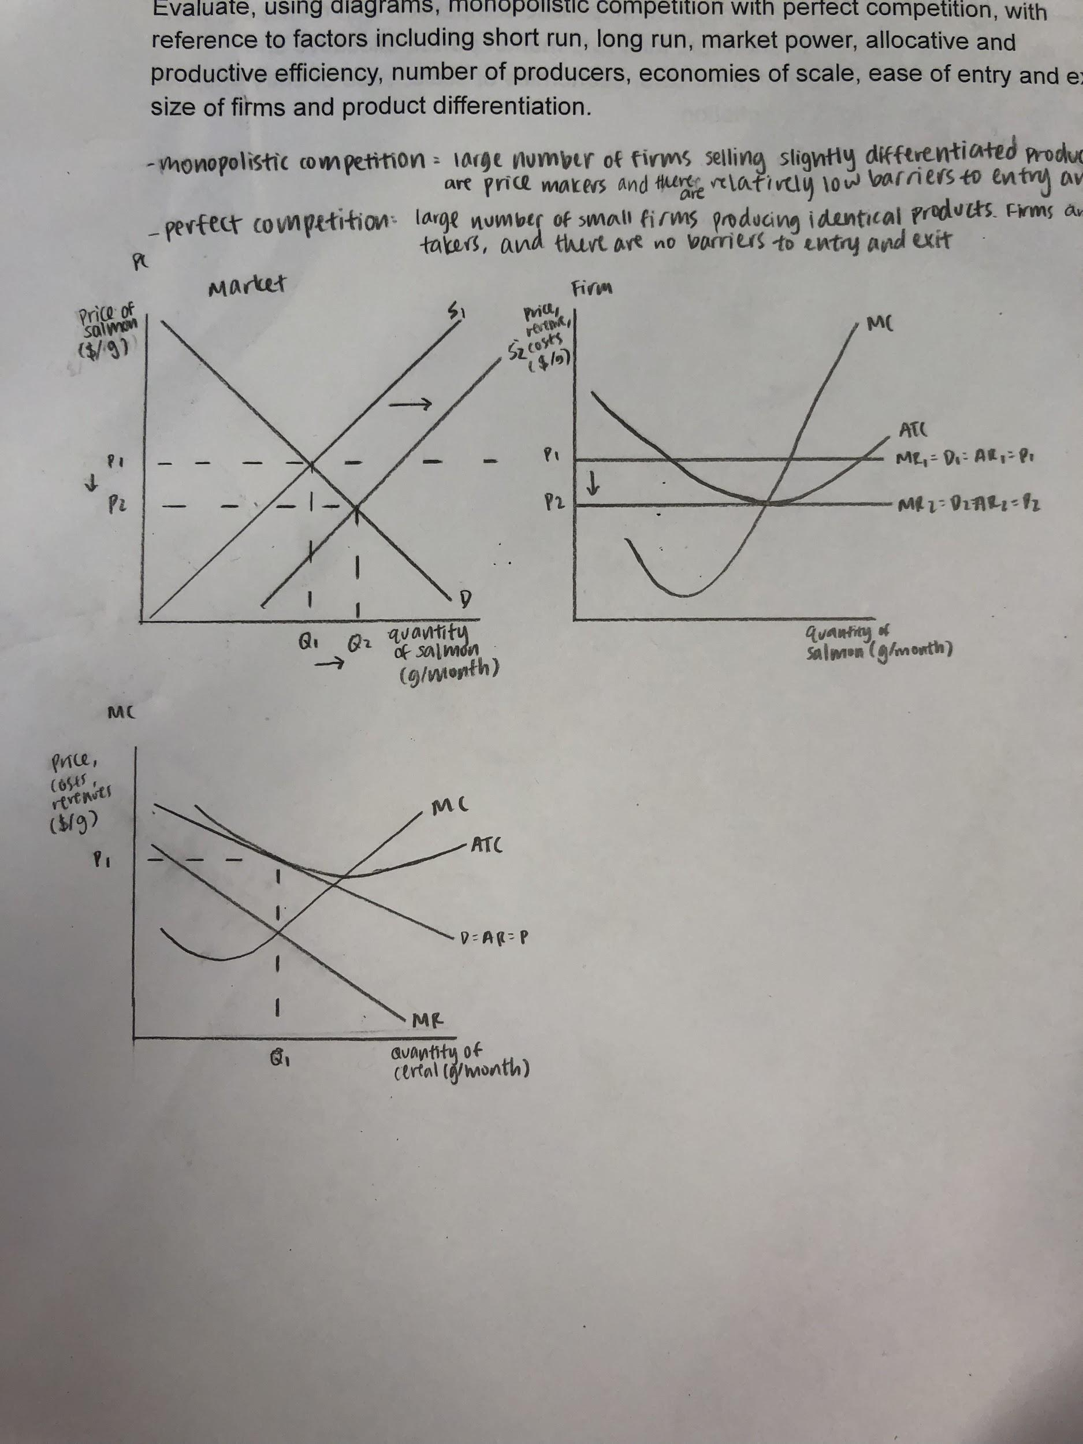
  + Perfect competition
    - At the current level of demand and supply, the price per salmon is greater than the typical firm’s ATC, meaning that individual firms are earning economic profits
    - Due to the lack of entry barriers, sellers of other products are attracted to this market, shifting supply to the right from S1 to S2.
    - This causes quantity supplied to move from Q1 to Q2, as there is more quantity supplied to the market.
    - This drives prices down from P1 to P2, as the availability of supply causes prices to drop.
    - In the long run, the market will reach a state of equilibrium in which the individual firm is breaking even.
  + Monopolistic competition
    - The firm is producing at its profit maximising quantity (Q1) and charging the price consumers are willing to pay for that quantity (P1)
    - In the long-run, price = ATC, so the firm is breaking even and only making normal profit
* Analysis (pros and cons)
  + Advantages: Monopolistic Competition
    - Firms have some form of control over their prices of their goods due to the existence of some form of product differentiation between firms.
    - Firms can make profits in the Long Run due to the opportunity to adapt to the market, allowing firms to innovate and differentiate their product in ways to benefit consumers.
  + Disadvantages: Monopolistic Competition
    - Because of the lack of competition, monopolistically competitive markets produce less than the socially optimal (P=MC) level of output
    - The price consumers will pay will be higher than in a more competitive markets, since competition does not force firms to produce and sell at their minimum average cost.
  + Advantages: Perfect Competition
    - Price is usually the lowest compared to other market structures
    - Perfect substitutes and perfect information available for consumers
    - Able to consume at the point where allocative efficiency can be obtained in the market, where P = MC, as firms are price takers and price is always at MR = MC
    - Productive efficiency, where P = min. ATC, is always achieved, as there are no barriers to entry and exit, the only firms who stay in the long run are those who are able to produce at min. ATC
  + Disadvantages: Perfect Competition
    - Every firm sells an identical product, lack of variety for consumers
    - Firms can only earn normal profit in the long run, no funding to support product innovation, quality of the good will not improve
    - Firm size really small, difficult for firms to achieve economies of scale
    - Firms are unable to alter their prices to meet their meets due to them being price takers, having no influence over market prices.
* Evaluation
  + Perfect competition model is too theoretical, assumption is unrealistic, difficult to apply in real life situations
  + In the long run, perfect competition will break even and only make normal profits, and there is nothing that an individual firm can further due to earn profits
    - With monopolistic competition, even after breaking even in the long run, firms have more ability to make profits through non-price competition and product differentiation
  + In perfect competition, firms achieve allocative and productive efficiency, in monopolistic competition, firms will not achieve either one
  + Showing the LR of the firm in monopolistic competition indicates that neither allocative nor productive efficiency is achieved
    - Comparing price with MC along vertical line at EQ level of output (Qe), price is higher than MC
      * Indicates underallocation of resources to production of good
      * Society would like more goods produced
      * Production occurs at greater minimum ATC
        + Therefore AC is higher than optimal point from society’s POV
  + Conclusion: Price is higher and quantity is lower in monopolistic competition than in perfect competition, and neither type of efficiency is achieved. However, due to the overly theoretical concepts of perfect competition, as well as the potential improvements in product quality and variety for monopolistic competition, it is probable that consumers and producers will ultimately benefit more from monopolistic competition in the long run.

